From ...student, click “fork”
Choose your account name
creates fork under your acct w/ same name

click settings, (icon of wrench on right-side column)

in box “repository name”, edit this to new name (e.g. cwru_376_wsn) and click “Rename”

now at new repo addr w/ new name (fig);
note message: “this branch is even with cwru-robotics:master”, meaning the new repo is up to date.

Next, made a simple change to the class repository (an edit to “README”).

Under: https://github.com/cwru-robotics/cwru_376_student, notice that “README” says it was updated 1 minute ago. (step6 fig)

Going back to the forked copy at: https://github.com/wsnewman/cwru_376_wsn,
we see the line “This branch is 3 commits behind cwru-robotics:master”

Click the button in this line labelled “Compare”
The claim “isn't anything to compare” is because we have nothing to contribute to the class repo. This will normally be the case—we typically will not fold in your work into the shared repo. However, you DO want to bring in changes from the class repo into your repo (e.g., new code I have posted for you). To do this, click the link “switching the base.” The web view comes up as follows: (step 9).

Note that the fields “base fork” and “head fork” have swapped places. You can also see the edits that were performed on “README”. We want to bring our fork up to date with the changes in the class repository. To do so, click on the large, green button labelled “Create pull request”. This is the mechanism to suggest folding in changes from repo1 to repo2. In this case, repo1 is the class repo, and repo2 is your personal forked copy. (step10: pull request)

Fill in “title” and “message” fields with something meaningful to you; I have put the title as “update my fork from shared repo” with the message “demo for class notes on git”. Next, press the button “Create pull request”. You will get a screen like the following:

Within our personal copy of the repo, we see that a “pull request” has been issued. It so happens we requested it of ourselves. As you work in teams, such requests may come from team members. In either case, you can accept the request (if that is a good idea). I typed in the comment “accepting update from class repo,” and clicked the “comment” button. To fold in the changes from class repo to my fork, I now click the button “Merge pull request.” The result looks like the following:
(step13). Note the comment “merged... a minute ago”.

Note also the line “this branch is 1 commit ahead of cwru_robotics:master.” It is OK for your fork to be ahead of the master (and this will be the case as you add your own code). However, you want to make sure your fork is not behind the master.

To continue the example, assume I am on a computer that does not already have a clone of my personal repository. In a command terminal, I create a clone of my repo with the command:
git clone https://github.com/wsnewman/cwru_376_wsn.git
I then “cd” to the resulting directory: cd cwru_376_wsn. The reason for requiring navigating into the repo directory is that “git” understands how to work with a repository by virtue of storing information about the repo in a hidden subdirectory of the repo called “.git”. (You can browse this and explore the files “git” uses, if desired, but normally you would not interact with the info here). Note that you could have multiple repositories on your system. Git only understands how to perform updates by referring to the unique .git folder associated with the repository of interest. Thus, you MUST navigate to somewhere inside your repository before issuing new git commands.

Having navigated to cwru_376_wsn in a command terminal, you may enter the command “git gui”, which will bring up a GUI-based git interface.

As an illustration, I edited the file lidar_alarm.cpp in my personal repo.

This is actually a bad idea. In my personal repo, I should not touch files (or even packages) that originate from the class repository. Owners of this repository might alter these files in the future (e.g. if Luc also edits lidar_alarm.cpp on the class repo). In that case, we would both

~/ros_workspace/cwru_376_wsn/catkin/src$ cwru_create_pkg demo_pkg roscpp nav_msgs geometry_msgs std_msgs

Within a command window, navigate to the repository of interest (ros_workspace/cwru_376_wsn) and enter the command:
git gui
A window appears that looks like this:
(step15)

The upper left box shows that we have 3 new files (which resulted from creating our new package).
Clicking on the name of the third one (package.xml) displays the contents of (or changes to) this file in the upper right box.

Clicking on the icons next to all three files prepares these files to be committed to be saved in the repo, and the gui will look like the following: (step16).

Next, click the “commit” button. Then click the “Push” button to send these changes to the repository stored on-line at github. A window pops up: (step17).

Again, click on “Push”. You will be prompted to enter your github user name and password. With conclusion of a successful upload, you will get a response looking like this: (step18).

Returning to your browser, and refreshing the github site, the display now looks like the following:
(step19).
Note the line “This branch is 2 commits ahead of cwru-robotics::master”. This reflects the fact that our personal repo now has changes that are not part of the shared repo. You can see the commit message we had entered: “saving new files from new package creation.” You can also click on the “Compare” button, and you will see the contents of the newly uploaded code. (step20).

Although our personal repo is now “newer” than the class repo, we will still want to fold in any new changes from the class repo. I next made a (minor) change to the class repo (adding a comment to a single file). After doing this and refreshing the github page, the display looks like the following (step21). Note that line: “This branch is 2 commits ahead, 1 commit behind cwru-robotics:master”. We are not concerned that our personal repo is “ahead”. That will be the case throughout the course. However, the fact that your repo is “behind” cwru-robotics means there are new changes in this shared repo that you want to merge into your personal repo.

Click on the “compare” button. We see how the shared repository is behind your personal repository: (step22).

We want to reverse the order for the comparison. Near the top of the page, there is a drop-down menu labelled “base fork:”, which is currently set to the shared repo. Change this to your personal repo. The screen then looks like this: (step23).

Click on the link “compare across forks,” to get this: (step24).

Using the drop-down menu next to the label “head fork:”, select the class repo, and the view changes to the following: (step24)

Here we see the changes I made to the class repo. You want to bring these changes into your personal repo, following the process already described above; click: reate pull request, create pull request, merge pull request, confirm merge. Your fork now includes the new changes from the shared repo.

Resolving merge conflicts:
You should avoid editing any of the files from the shared repo. Instead, create new packages and, as desired, copy/paste shared code into your own package for editing. This will prevent conflicts between the class repository and your own repository. However, as you work in teams, you may find that you and a partner have both edited the same file. Here is an example.

User 1 clones a repo, then edits one line of CmakeLists.txt file in demo_pkg, adding the line:
cs_add_executable(example src/example1.cpp)

User 2 clones the same repo, and user 2 also starts editing the same CmakeLists.txt file, instead adding the line:
cs_add_executable(example src/example2.cpp)

User 1 commits and pushes her code first. User 2 is now out of sync.

User 2 then attempts to do the same, but the “push” command issues this error:
(step xx).
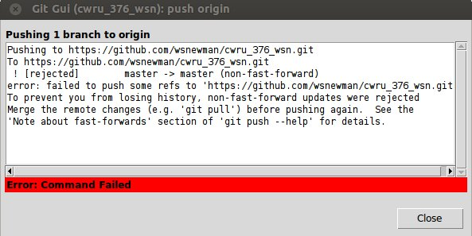

User 2 then attempts to sync with the remote repository, issuing a “fetch” command:
(stepxx)
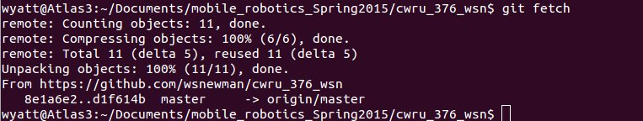

Followed by a “merge” command:
(step32), which produces the following error response:
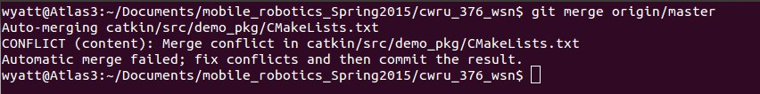
We need to resolve the conflict before we can proceed. A tool to do this is:
git mergetool
Which brings up a GUI, in this case: (step33)
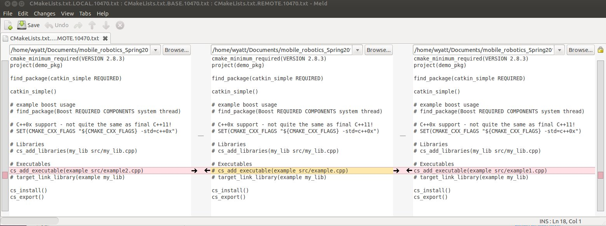

We see in this view the file before either user1 or user 2 edited it. We see on the left the edit user 2 attempted, and on the right is the edit user 1 performed (highlighted).

I choose to click on the arrow next to user 2's edit, producing the following result: (step34).
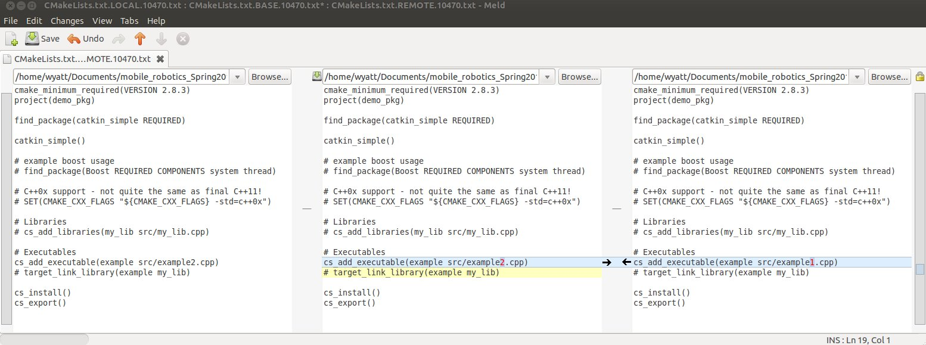

Note that this will wipe out user 1's edit. You can, alternatively, make changes that accommodate both edits (if that is compatible). Else, you will need to work out with your partner which change to accept.

We choose: file->save from the mergetool menu, then quit the mergetool program.

User 2, returning to git gui, sees the modified file ready to be saved. Clicking on it yields: (step35)
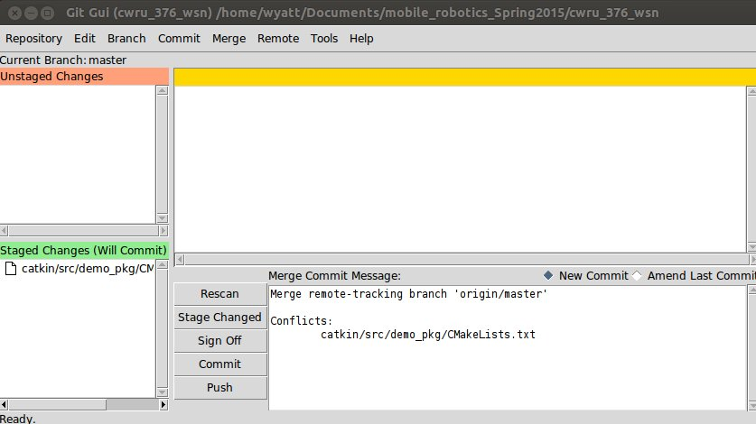

Note that a message has been inserted recognizing a merge conflict was addressed. After committing and pushing, we get a success message from github.

When user 1 next performs either a new clone, or performs a fetch and merge, user 1 will find her original edits from this document are gone and replaced with the merge conflict resolution performed by user 2. Both users are now back in sync with the repository.

